**Placement Report**

**Introduction**

For my placement I worked at Prestige Designz who are based in Leicester and are rated one of best Web Developers in Leicester. Other services they provide also include Graphics Design; Printing and Signage; Video Animations and Photography. Their main clients include companies who are freshly starting up or existing ones that need help creating websites or update/maintain their existing websites; design and print business cards; flyers, signage and fitting. In other words, they’re well known for helping new businesses start and help set up everything for them that may be essential.

Few of their well-known clients include ‘Mumtaz’, who were chosen to cook for the queen at an event at University of Huddersfield back in 2007. Prestige Designz have also done graphics design work for some Leicester City FC players (not allowed to disclose names) in the past. They have also done branding work for Amir Khan who is a professional British boxer and former world champion as well as for his missus who is a model. Apart from these clients who are very well known thought out the country, Prestige Designz have also worked with clients that are well known in Leicester, such as SKR Legal Solicitors and Dr Slush (have many branches across the UK) to name a few.

My role in the company was mostly helping doing the front-end for the website as well as doing graphics design work such as designing logos (for websites, signage etc); flayer, business cards, menus. I mostly used HTML and CSS languages as front-end languages and occasionally some JavaScript. When I first started my placement, I was only working on smaller scale web development projects and occasionally graphics design projects; mainly logo design. But as I improved at my role and got better at the job, I was assigned to bigger projects for web development and given more variety of jobs for graphics design work instead of just designing logos. I had some knowledge on HMTL and CSS before starting, however I had to learn everything from scratch when it came to graphics design.

**Activities**

Out of all the projects that I have done, the project which I will never forget is my very first graphics design project which got approved by the customer. Normally when I created, for example logo designs etc, they customer wouldn’t like it as it always lacked something thus Jeovorne or someone else had to give it the finishing touches. That’s why this project is one of the main turning point for me as i was starting to have less and less confidence in my graphic design skills since my work was never approved. For this project I had to create a logo and a promotional leaflet for a Caribbean food centre called ‘Hot Pot’ with their menu on the back. I first did some research and concluded to have the Caribbean colour theme on the leaflet. I started with the logo design for which I thought I should play with the word ‘Hot Pot’. I told Jeovorne of my idea and he really liked it and encouraged me to try it. So, for ‘Hot’ I wanted to add something which symbolised hotness, so I thought of replacing the letter ‘T’ in the word using a red chili instead. However, it didn’t look right to be, so I decided to use a flame instead of the letter ‘O’ which looked great. So, for the word ‘Pot’, I substituted the letter ‘o’ for an actual pot’. After finishing it, I sent it off to Ali for some feedback, but he approved it straight away. I then started working on the leaflet design which took longer than expected as I was keep having to make changes. I also struggled as this was my first leaflet design, so I didn’t know how to approach it and where to start. So, like with any project, I started with some research on leaflet designs and when I had a design in mind, I started working on it. I use the Caribbean colour scheme as the background and used some Caribbean cuisine pictures too. After making the front side of the leaflet, I proceeded to work on the back side where I had to put their menu. I used different colours and pictures to make it more eye catching. After having it approved by Ali, we had a meeting with the client to show them the finished leaflet, and he really liked the way I had designed it which helped me with my confidence and helped me believe in myself a bit 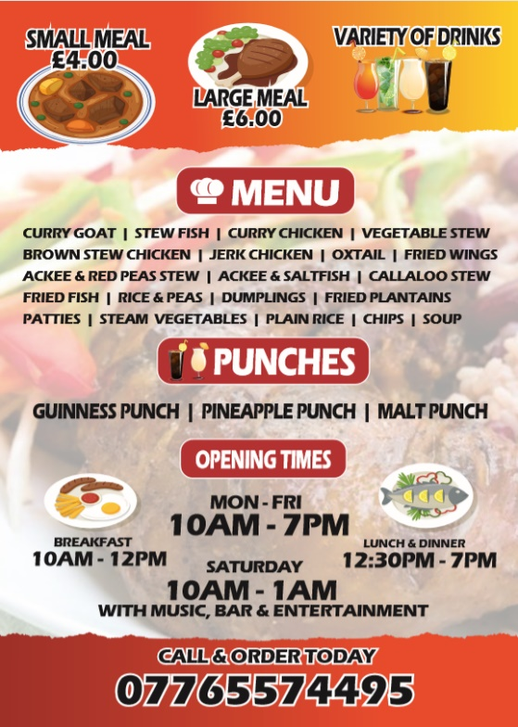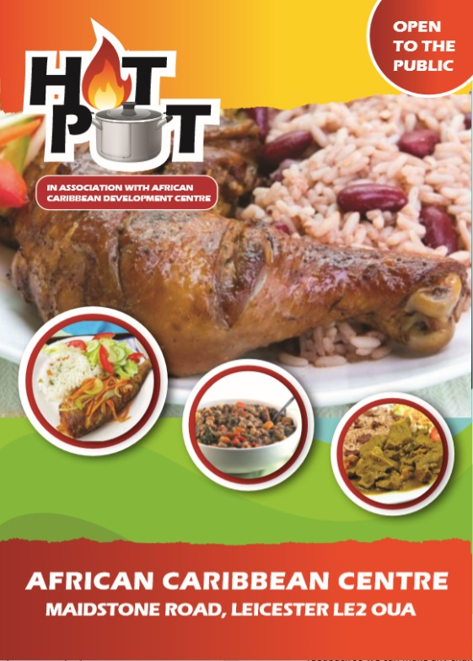more.

One of the most memorable projects I enjoyed working on was a creating a family board game for a client which, if I had to describe, was like snake and ladders as it followed the similar principle (not allowed to disclose too much information on the project). It was a very big project which I took a great pleasure being part of. We were required to design the game from scratch, do logo design for the game; logo design for the company logo (as this was their very first project and they plan on making more in the future); packaging and design for the packaging; website for the company which will contain everything about the company and all their products. I was first assigned to make few logo prototypes for their company logo while Jeovorne and few others worked on the packaging for the game. First, I did some market research and looked at other board games and such as monopoly, Ludo, Snake and Ladders etc. After doing research I concluded that I had to make the logo design colourful and eye catching as the target audience were kids. After creating a few logo designs, I sent them to Ali for some feedback. After making the improvement, I once again sent them to Ali for feedback; this process was repeated a few times until he was satisfied with the designs and approved them. Once the designs had been approved, we arranged a meeting with the client. The client had a monthly meeting scheduled with us monthly so we can keep her up to date on the progress of the project as well as so she can provide us with feedback so we can make any changes she requires. This will help us make sure we are meeting the client’s requirements at every step, so we don’t have to go back and change things when the project has come far. During the meeting, she didn’t like any of the designs and gave us her feedback. The one thing which she liked about the designs I had done were the colour scheme which she wanted to keep. After we had discussion about the logo design with the client, we then got feedback on the designing of the game which Jeovorne and Omarji oversaw. After making the changes which she had wanted, I designed 3 more logos and after getting them approved by Ali, another meeting with the client was arranged. The second time she liked one of the designs and approved it. Now I was in-charge of creating the packaging design (the picture that goes on the front of the box where the game name is etc). I again started with doing some research first, so I have an idea what to make. After doing some research I created four designs and got them approved after getting feedback for Ali. I was really liked 1 of the four designs and was very confident and convinced that the client would choose this as it portrayed the game very well and believe to be my best work thus far. Even my teammates were convinced she would choose this design, however, when we had the meeting with her, she didn’t like none of the designs at all. I was very upset, and dishearten and my confidence took a very big blow. It was so bad that I just couldn’t think of any other designs to make and was upset for a few days, so Brisco had to pass the job onto someone else and I was told to make start on the website instead and make a landing page (it means that the website wont contain much content, just design the website and publish it first for exposure and make a page saying “Coming Soon” or something). I started by using a template which I had used for another project. The website didn’t take very long to do as it didn’t contain much content thus, I got it approved by Brisco straight away. I was then assigned to work on the designing of the game with Jeovorne’s team. While working on the game, my placement came to an end, so I didn’t get to see the finished product sadly.

Another project I would like to mention is a website project I did which was in individual project. One of the main reasons why I liked this project was because this website looked very professional and I was very satisfied with it as it was fully responsive and looked good. The website was about selling supplements and aimed at people that go to the gym. I didn’t have to do much research for this as I previously had experience buying supplements online. I started by using a template which I had from other projects. I used bootstrap framework throughout the website which made things simple. I started by creating the logo on illustrator for the website, and then created the home page; then the rest of the pages. I was first having troubles finding the right pictures to use because they can have a very big impact on your website. I had to spend a very long time finding the right pictures to use. Another thing I was struggling with was making the website responsive as I was unaware of the features bootstrap provided for making your website responsive. After trying by myself, I went to Ali for advice and he was the one who made me aware of it which made things a lot easier and the code cleaner. After I finished the website, I sent it off to Ali who gave me some feedback. After applying the changes, we arranged a meeting with the client who liked how the website looked.

**Achievements**

This section should reflect on the changes in your technical/scientific, professional and personal skills as a result of your placement. It should demonstrate self-awareness by acknowledging mistakes made and showing evidence of attempts to overcome deficiencies. It should identify growth as well as areas for future development.